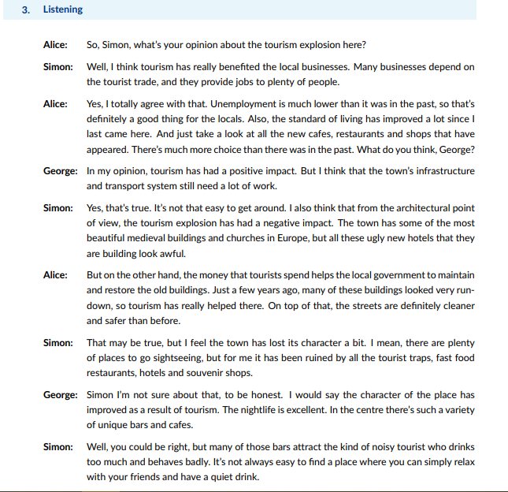

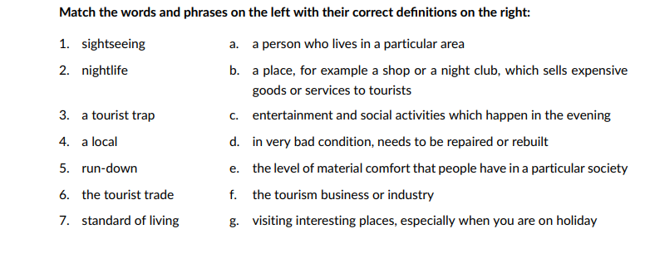

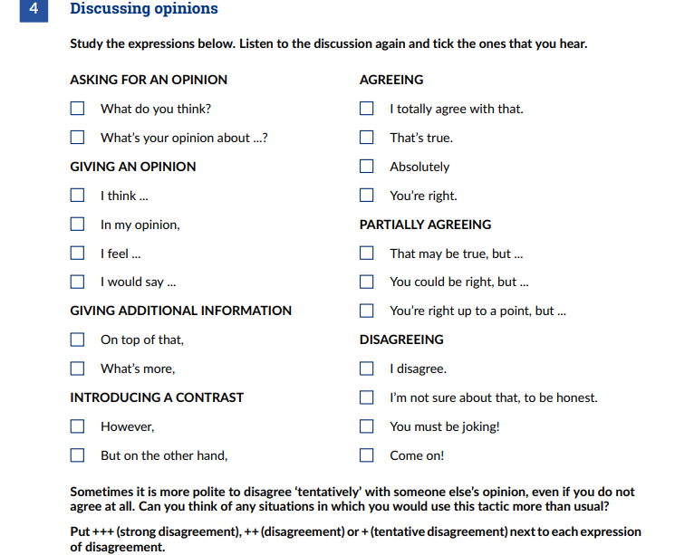

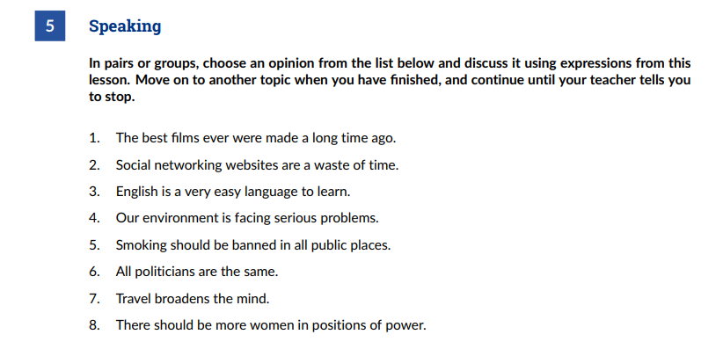

1. I’m not sure about that, to be honest.

Say a film do you like?

1. I disagree, they are necessary for communication between people.

Why don't you like social network?

1. That’s true, but you need a lot of time to learn.

Why do you think that?

1. Absolutely, the climate change bring serious problems to the world.

Do you agree with me?

1. I totally agree with that.

How do smokers think?

1. I disagree.

You don't like politics?

1. I totally agree with that.

Where have you traveled?

1. You’re right, we need change that.

What we can do?